Here is the explanation of how works the Confirmation email section of the “Subscription form”:

First of all, this section is available only if the configuration of your form includes an email field. Otherwise this section is masked.

If you don’t want to send a confirmation email just delete all the data in each fields (you need to insist in the Message text field to really delete everything)

You can add in the message or in the Subject a couple of merge fields (this depend of your confirguration). Clic on a merge field and click where you want to drop it.

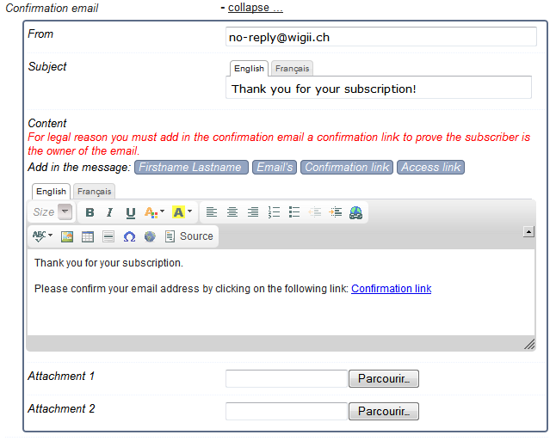

Confirmation link is a link to let the email owner to confirm his email. This is very important for legal issue. The confirmation proof is stored in Wigii and could be used in case of spam complain.

Access link will give to people the ability to update their subscription during the subscription timeframe.

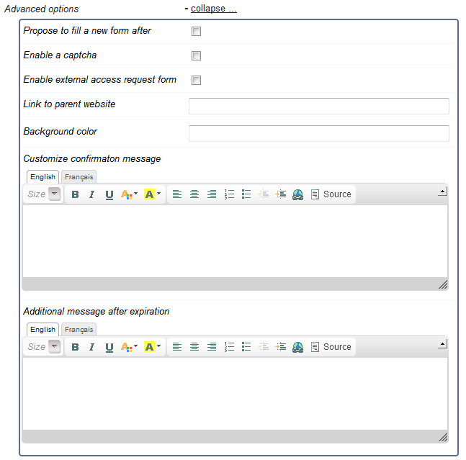

Propose to the subscriber to fill an other subscription after done.

Add a captcha code to fill (prevent robots).

This will create an extra link you can use to let people request a link to update their own data.

If something is defined here it will replace the “Thank you for your subscription” default text.

The additional message after expiration is message displayed if the form is closed (because of timeframe or max number of subscription)